**Celebrating Seventy Years of Recovery**



A Guideline for Workshops using

***Many Voices, One Journey* (B-31)**

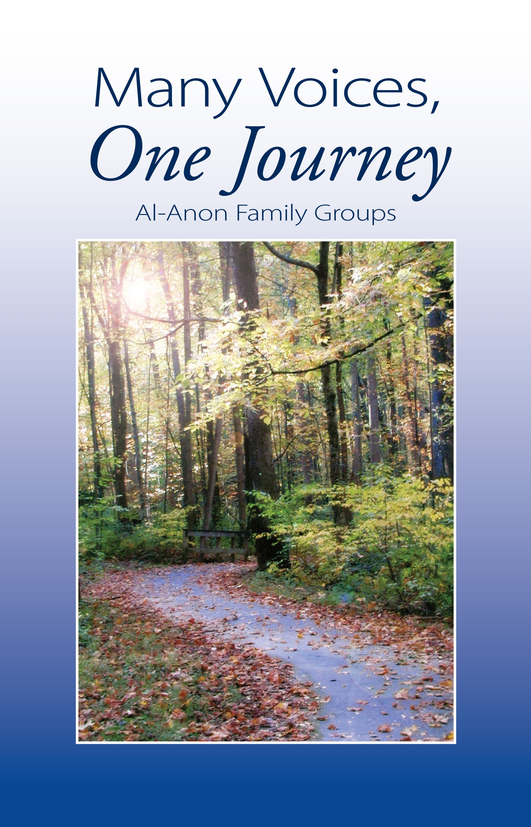

Save the Date! District 12 Winter Workshop

January 29th, 2022, Registration 8:30 am

Workshops and Round Robin - 9:00am -1:00 pm

Continental Breakfast provided

Also On Zoom! (See info page two)

Held at the Fairview United Methodist Church

4601 Avonia Rd. Fairview, PA

Distributed by Al‑Anon Family Group Headquarters, Inc. This handout may be photocopied.

Catherine-North East, PA is inviting you to a scheduled Zoom meeting.

Topic: Celebrating Seventy Years of Recovery - Many Voices, One Journey Workshop  
Time: Jan 29, 2022 08:30 AM Eastern Time (US and Canada)

**We are asking members to please register for the Free Workshop**

**either In-Person or on Zoom.**

**Please email or text Liz T. by January 26th, 2022**

[**lizgreent@gmail.com**](mailto:lizgreent@gmail.com) **or 814-4345194**

**We would appreciate getting a count so we will know how much food for the In-Person Meeting and to plan for breakout rooms if needed on Zoom.**

**We are very excited and hope to see you there!! 😊**

Join Zoom Meeting  
<https://us02web.zoom.us/j/83185066271?pwd=N2dHYUo1QkRaK1VuUTl5TUl6VzdMZz09>  
  
Meeting ID: 831 8506 6271  
Passcode: recovery  
One tap mobile  
+13126266799,,83185066271#,,,,*75615146# US (Chicago)  
+16465588656,,83185066271#,,,,*75615146# US (New York)  
  
Dial by your location  
        +1 312 626 6799 US (Chicago)  
        +1 646 558 8656 US (New York)  
        +1 301 715 8592 US (Washington DC)  
        +1 346 248 7799 US (Houston)  
        +1 669 900 9128 US (San Jose)  
        +1 253 215 8782 US (Tacoma)  
Meeting ID: 831 8506 6271  
Passcode: 75615146  
Find your local number: <https://us02web.zoom.us/u/kc5qntfNtt>

**Seventy Years of Recovery**

To prepare for the workshop, first select the topic (or topics) to be covered from the following list:

1. **Change**
2. **Control**
3. **Denial**
4. **Growth through Service**

The list of workshop topics covers certain themes and subjects that are covered over a 60-year period in *Many Voices, One Journey*. You may wish to include the specific topic(s) in any announcements for the workshop. You may wish to select a few members to give the material to ahead of time and ask them to be prepared to begin the discussion and initiate conversation, once the material for the topic has been read aloud. Depending on the size of the audience, you may wish to allow 30 to 60 minutes per topic.

1. The Moderator opens with the Serenity Prayer and Al‑Anon Preamble. Then the moderator briefly introduces the specific subject (see list of four topics above), and explains that the format of the workshop will include a brief reading of text and a question from *Many Voices, One Journey* (B-31), Al‑Anon’s new book on 60 years of recovery. This will be followed by discussion, in which all attendees are invited participate.
2. Using the chosen topic(s), ask one or more attendees to read the selected text and questions from *Many Voices, One Journey*. (See the following pages for readings and questions.) A handout sheet with the topic, excerpt, and questions is also given to all participants.
3. Members are now invited to briefly address the topic and/or questions in front of the entire group.
4. Summary by Moderator, suggesting that now this discussion has begun, we can continue exploring it among program friends, Sponsors, and at meetings. The new book can be a tool to help us look at how Al‑Anon’s growth as a fellowship is connected to our own personal growth. End with Suggested Al‑Anon/Alateen Closing.

**Topic Choice One**

**Change**

**Readings:**

**1977**

From pages 194-5

"*I did not take a Fourth Step inventory until I was in Al‑Anon for about 14 months. I was afraid it might change me and therefore break up my relationship with my partner. And it did change me—I stopped criticizing, yelling, and screaming. Surprisingly, my partner never resented my going to meetings. He also knew that I needed to go, and that if I didn’t, I could die, as I constantly thought of suicide. It took me about four years to realize I had finally achieved serenity from going to Al‑Anon meetings.*”*

**2011**

From page 384

“*I often hear longtime members talk at meetings and conferences about how Al‑Anon ‘used’ to be. They question the direction it is taking now, and feel that the program just isn't true Al‑Anon anymore.*

*I don't know how Al‑Anon ‘was’ back in those days. I only know what it has been for me the past ten years. I know that it is working for me. It has given me a life filled with serenity and joy, in spite of the ongoing alcoholism in my family. Those same longtime members are the ones who inspired me and shared with me that life* is *all about change. When I changed, everything changed.*

*It probably is true that Al‑Anon is not the same as it used to be. However, nothing is the same as it used to be. Life* is *all about change. It is about our willingness to be open to this change—to use these opportunities for growth and to fall back on the Steps, Traditions, and Concepts of Service to keep the program in check.*

*The program has also taught me that we can't go back in the past, but we can use those experiences to improve what's happening now. The bottom line is that the program is in the hands of a Power greater than ourselves. I think Al‑Anon couldn't be in better hands.*”*

From page 390-1

“*I used to think of change as the ultimate threat to my security, as if my well-being could only be maintained by making sure everything stayed exactly as it was. I felt like I was standing on a fault line, paralyzed by the possibility that if I moved a muscle, I might be swallowed through the cracks at any moment. Looking at Al‑Anon’s past has taught me to stop being afraid of change. . .*

*Growth cannot occur without change, and our history as a fellowship is a long, continual series of changes. As Lois wrote on page 195 of* Lois Remembers, ‘*. . . stagnation is retrogression. There is no standing still.’ Our history has also taught me that change need not be painful, and that as long as I hold on to those spiritual principles that are most clearly part of my essential identity, I can continue to change, grow, and transform without fear of losing myself or my way.*”*

**For discussion:**

1. What are my feelings about change?
2. How has my attitude changed since joining Al‑Anon?
3. How has the way I practice my program changed since I joined?
4. How has the Al‑Anon fellowship changed?

*From *Many Voices, One Journey*, copyright 2011 by Al‑Anon Family Group Headquarters, Inc. Reprinted by permission of Al‑Anon Family Group Headquarters, Inc.

**Topic Choice Two**

**Control**

**Readings:**

**1925**

From page 6

“Lois W. had a secret motive when she and her husband, Bill, left New York City in 1925 for a year as ‘motorcycle hobos.’ Bill wanted to discover investment opportunities by visiting companies across the country and learning about them first-hand. Lois wrote:

*My reasons for wishing to take the time off were quite different. Although I thought Bill’s stock theories were sensible, I wanted to get him away from New York, with bars (saloons they were called then) on many corners, and away from his buddies, both of which I considered contributed greatly to his excessive drinking. A year in the open, which we both loved, would give me a chance to straighten him out.*”*

**1963**

From page 119

“The 1963 World Service Conference did not come to agreement on the content for a new book, planned to debut at the International A.A. Convention in 1965. ‘Some thought the book should contain interpretations of the Twelve Steps and Traditions, while others felt we needed a history of Al‑Anon with chapters by interested outsiders, such as clergymen, doctors, welfare workers, etc.’ The Conference members decided to leave the final decision to the Literature Committee. Meanwhile, all Delegates would ask the membership in their Area to submit sharing’s on the Steps and Traditions, while contacting outside agencies and asking them to express their opinions about Al‑Anon.”*

**2000**

From page 326-7

“When re-typing *One Day at a Time in Al‑Anon* (B-6), the WSO staff discovered that numerous housekeeping changes had been made between 1978 and 1998, despite the 1978 Conference decision that no changes could be made to the book without majority approval of the full Conference…

The Conference declined ‘to approve all text changes made to *One Day at a Time in Al‑Anon* between 1979 and 1999’ with a single motion. Instead, the Conference approved 14 separate motions for changes, and rejected five others. For example, Motion 28 authorized the WSO to capitalize the slogan ‘Let Go and Let God’ on p. 95. Motion 33 authorized the WSO to capitalize the slogan ‘Let Go and Let God’ on p. 361…

These motions took the Conference well into the night. To avoid this type of session again, the Conference also approved a motion that authorized the Executive Committee to approve housekeeping changes to *One Day at a Time in Al‑Anon,* beginning with the 1979 edition of the book. Any proposed text revisions would still need to come before the entire Conference, but the Conference would not have to spend time on details such as updating addresses, correcting misattributions, etc.” *

**For discussion:**

1. What have I done to try to manage someone else’s drinking?
2. How do I find the appropriate balance between maintaining control and letting go?
3. When have I taken too much detailed control, and realized that it was self-defeating not to delegate responsibility to others?

*From *Many Voices, One Journey*, copyright 2011 by Al‑Anon Family Group Headquarters, Inc. Reprinted by permission of Al‑Anon Family Group Headquarters, Inc.

**Topic Choice Three**

**Denial**

**Readings:**

**1979**

From pages 204-5

“’The Elephant in the Living Room,’ a sharing by a member in Virginia, was printed in the April 1979 edition of *The Forum.* Although probably not the first time this metaphor was used to describe the denial common to alcoholic families, this story greatly popularized the term throughout Al‑Anon:

*So there the dumb thing sits—it’s called alcoholism, and it’s the biggest thing in the house. Other people can entertain, other children can have friends sleep over. Your house is full of elephant!*

*So you flail at it, cry over it, push the tail end, pull the trunk end, and try to coax it into joining the circus—but there the dumb thing sits.*

*Some of us spend so much time pushing and pulling our own private pachyderm around that we never really do anything else. Our children go on with their lives the best they can, and every now and then we leave off shoving long enough to throw a little comment of criticism at them—but we run back to our primary occupation.*

*Now, isn’t that silly? You can’t move an elephant! You can move out—or you can go on with your life the best way possible considering the irrefutable fact that there is an elephant in your living room. You can learn to live with it . . . roller skate around it . . . dust it off . . . crochet a nose-cosy for it . . . paint it puce and purple . . . rent space on it to the political candidate of your choice . . . but STOP TRYING TO MOVE IT!!!*

*. . . and smile. God loves you, and He gave you the whole world to be happy in—not just the little space around the you-know-what in your you-know-where.*”*

**2001:**

From pages 336-8

“*I first started hearing about adult children meetings in the mid-1980s…My first reaction was that it would be okay, but only if they were willing to cease using outside literature, stop whining about lack of nurturing, quit all that ‘inner child’ talk, and get beyond Step One. I thought, ‘Just suck it up and grow up.’ In other words, be like me…*

*There was a lot of fear and animosity about this issue in our Area at the time. It was a very hot topic! Despite a little reluctance on my part, I did what I could to work toward* *the unity of our fellowship, helping us all see and share what we had in common. But regardless, they weren’t like me…*

*In 2001, I was attending a Regional Service Seminar in Ontario with Al‑Anon friends...After I told some of my experiences as a child, one of these friends asked me if I could possibly be an adult child. I replied, ‘Of course not!’ But then the light bulb went on, and I admitted, ‘Yes I am!’ Not only are they like me, but I am like them!*

*Until that moment, I really didn’t believe that I had been raised in an alcoholic home. Nobody really drank in my immediate family. I had never connected my maternal grandfather’s drinking to myself or to my family. I had denied the effects that alcoholism had on my mother, and I had refused to deal with the alcoholic behavior of my mother, or any consequences it had on my upbringing.*

*I wasn’t being intentionally dishonest or untruthful—it had just never occurred to me. Denial is like that. I think it was God’s way of protecting me from the truth until I was ready to handle it.*”*

**For discussion:**

1. How has denial affected my response to alcoholism?
2. What part has denial played in my life before Al‑Anon, and during my recovery?

*From *Many Voices, One Journey*, copyright 2011 by Al‑Anon Family Group Headquarters, Inc. Reprinted by permission of Al‑Anon Family Group Headquarters, Inc.

**Topic Choice Four**

**Growth through Service**

**Readings:**

**1942**

From page 20

“Another ‘Anne,’ Al‑Anon cofounder Anne B., first met Lois late in 1942, shortly after a doctor suggested that Anne find some help for her husband. Anne was 43 years old, and had been married for more than 20 years.

“After several years, Anne came to understand that she could also benefit from A.A.’s Twelve Steps:

*…I had been the most fearful person: afraid of everything . . . afraid of animals, the dark, thunderstorms, and people. As I grew older, people were my greatest fear. Even approaching the program, I still was fearful. I'd go to A.A. meetings but still really was afraid of meeting people. I was very shy; I was the greatest introvert on record...*

*Eventually, with the help of Lois, a Westchester Family Group was formed . . . After I entered into family group activities, had taken the Step of acceptance, then of conversion, the Third Step came along—the Step of dedication. Then I really began to progress, because I was helping others; trying to give them something I had experienced. If it was no more than just giving out literature, a book to read, or a word of encouragement, it was a part of Twelve-Step work. Possibly my experience wasn't great enough to help some, but that I was able to help at all was a step to progression, and I feel now that I'll never stop progressing.”\**

**1965:**

From pages 122-3

“A member from Missouri shares:

*My first meeting was at an open A.A. meeting in 1965. There wasn’t an Al‑Anon Group in Columbia at that time; we got one started the next year. Shortly after that, my Sponsor received a letter asking her to give a ten minute talk on sponsorship at a district meeting in Marshall, Missouri. She asked me to go with her, but I said no. She told me she would buy my lunch. Since no one had ever offered to buy me lunch before, I agreed to go.*

*In 1965, there were seven districts. District 5 covered all of Missouri from Kansas City to St. Louis, up the Iowa line and down almost to Arkansas. Then we split it down the center to form District 8 and have continued adding districts. District Representatives were called Committeemen back then.*”*

**For discussion:**

1. Anne B. said she was “the greatest introvert on record,” and yet she went on to be a Chairman of the Board for Al‑Anon. She believed that Al‑Anon service played a very important role in her recovery. What part has Al‑Anon service played in my own recovery?
2. Most success stories in Al‑Anon service begin with the positive encouragement of someone else who is already involved in service. How did someone play that role in my Al‑Anon service? How did I pass that encouragement on to someone else?

*From *Many Voices, One Journey*, copyright 2011 by Al‑Anon Family Group Headquarters, Inc. Reprinted by permission of Al‑Anon Family Group Headquarters, Inc.