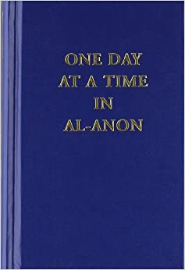

Eastside Readers AFG

10th Anniversary

Celebration

Come help us Celebrate!

October 13th, 2021

Location: Emmanuel Presbyterian Church

3520 Perry Street

Erie, PA

Time: Potluck starts at 7:00 pm

Meeting begins at 8:00 pm

Al-Anon Lead: Chris W. North East, PA

AA Lead: Mike W. North East, PA

Hybrid Zoom ID# 946 6029 9293

Zoom Password: 472323

