SAVE THE DATE
Formerly known as the Weekend of Sharing, this year is a Day of Sharing
When: September 11, 2021

Where: Camp Fitch

Time: 9 am – 8 pm (registration @ 8:30)

Theme: Many Voices One Journey

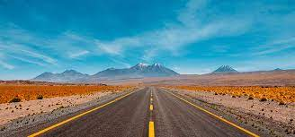

Workshops: One Day at a Time
Let it Begin with Me
Hope for Today

Speaker: Barb Lee

