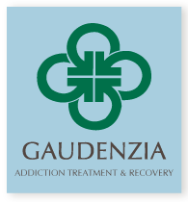 GAUDENZIA
Helping People Help Themselves Treatment Program
414 West 5th Street
Erie, PA 16507

VOLUNTEERS NEEDED
Volunteers are needed to participate in an Al-Anon meeting to share experience, strength, and hope with family/friends of Gaudenzia clients.

The meetings will take place on the following Sundays at 1:00 P.M.

March 8th April 19th
May 31st July 12th
August 23rd October 14th
November 15th December 27th

Volunteers need to arrive before the doors lock at 1:00.

If you have any questions, contact Charlotte at majorlioness45@gmail.com

